Table of Contents

Adventurer Mission Statement----------------------Page 2
Adventurer Theme Song-------------------------------Page 3
Adventurer Law and Pledge---------------------------Page 4
Adventurers Meeting Dates and Activities--------Page 5-6
Insignia Placement--------------------------------------Page 7-8
Books of the Bible---------------------------------------Page 9
Ten Commandments-----------------------------------Page 10
Psalms 23--------------------------------------------------Page 11
Lords Prayer----------------------------------------------Page 12
Consent Forms-----------------------------------------Page 13-17

Restoration Praise Center Royals Adventurer Club Mission Statement
(Adapted from the NAD Adventurer Ministries Mission Statement)
The North American Division Adventurer program serves an intercultural community of children in grades 1-4 (and below) and their parents and care-givers through a holistic ministry.
The purpose of the program is to support parents and care-givers in leading and encouraging their children in a growing, joyful love relationship with Jesus Christ.
It offers instructional curriculum, family enrichment, supplementary resources, and volunteer training from within the Seventh-day Adventist philosophy.
The Adventurer program should work to fulfill the gospel commission (Matthew 28:18-20) and depends on the support of a congregation strong in mission and empowered by the Holy Spirit.

Adventurer Club Theme Song

We are Adventurers; at home at school at play.
We are Adventurers; we’re learning every day.
To be honest, kind and true.
To be like Jesus through and through.
We are Adventurers! (Repeat)

We are Adventurers; at home at school at play.
We are Adventurers; we’re learning every day.
To be honest, kind and true.
To be like Jesus through and through.
We are Adventurers!

Adventurer Pledge
Because Jesus loves me, I will always do my best.

Adventurer Law
Jesus can help me to:
Be obedient
Be pure
Be true
Be kind
Be respectful
Be attentive
Be helpful
Be cheerful
Be thoughtful
Be reverent.

Meeting Dates and Activities
2015-2016 Adventurer Schedule

OCTOBER
Sabbath October 10: FIRST ADVENTURER MEETING: Basic Requirements

Sabbath, October 31: CPC Adventurer Day

NOVEMBER
Sabbath, November 7: Induction Program/ Family Blessing Service and Candle Lighting Program- Class A Uniform Inspection

Sabbath, November 7: Adventurer Meeting/ Begin My God Requirements- Earn Awards

Sabbath, November 21: Operation Christmas Child Box Packing

DECEMBER
Sabbath, December 5: Adventurer Meeting: Complete My God Requirements- Earn awards

Sunday, December 19: Field Trip: First Church of Glen Arden Christmas Production***

JANUARY
Sabbath, January 9 : Adventurer Meeting: Begin My Self Requirements

Sunday January 16: Field Trip: Indoor Rock Climbing/ Fitness Camp***

FEBRUARY
Sabbath, February 6: Adventurer Meeting: Complete My Self Requirements- Earn Awards

MARCH
Sabbath, March 5: Adventurer Meeting: Begin My Family Requirements

Sunday, March 19: Field Trip: Port Discovery-Baltimore Inner Harbor***

APRIL
Sabbath, April 2: Adventurer Meeting: Complete My Family Requirements- Earn Awards

Sunday April 24: Potomac Conference Fun Day

MAY
Sabbath, May 7: Adventurer Meeting: Begin My World Requirements

Sunday, May 21: Field Trip- Watkins Park Nature Center***

JUNE 2016

Sabbath June 4: Adventurer Meeting: Complete My World Requirements- Earn Awards

Sunday, June 12: End of year trip to Kings Dominion Water Park

Sabbath, June 18: Adventurer Sabbath /Investiture Service

***Locations and Dates are subject to change.

Uniform Insignia Placement

LEFT SLEEVE
The Adventurer World emblem is to be worn on the left sleeve 1 ½ “ below the shoulder seam.

Uniform Insignia Placement
RIGHT SLEEVE
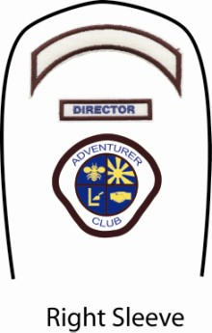
The Adventurer Club name crescent is to be worn ½’’ below the shoulder seam.

The Adventurer Club Emblem is to be worn
2 ½’’ down from the shoulder seam.

The Books of the Bible

The Ten Commandments
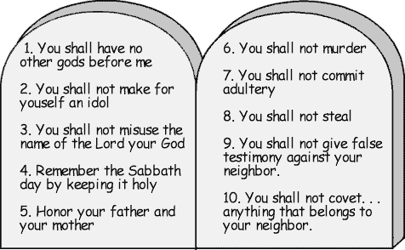

Psalm 23

The Lord’s Prayer

Field Trip Consent Form

I, ______________________ will be attending the field trip to________________________.
I will proudly wear my Adventurer shirt and adhere to the Adventurer law. I will be cheerful, helpful, honest, kind and courteous.

Signature of Parent or Guardian

Address

Emergency Contact

Field Trip Consent Form

I, ______________________ will be attending the field trip to________________________.
I will proudly wear my Adventurer shirt and adhere to the Adventurer law. I will be cheerful, helpful, honest, kind and courteous.

Signature of Parent or Guardian

Address

Emergency Contact

Field Trip Consent Form

I, ______________________ will be attending the field trip to________________________.
I will proudly wear my Adventurer shirt and adhere to the Adventurer law. I will be cheerful, helpful, honest, kind and courteous.

Signature of Parent or Guardian

Address

Emergency Contact

Field Trip Consent Form

I, ______________________ will be attending the field trip to________________________.
I will proudly wear my Adventurer shirt and adhere to the Adventurer law. I will be cheerful, helpful, honest, kind and courteous.

Signature of Parent or Guardian

Address

Emergency Contact

Field Trip Consent Form

I, ______________________ will be attending the field trip to________________________.
I will proudly wear my Adventurer shirt and adhere to the Adventurer law. I will be cheerful, helpful, honest, kind and courteous.

Signature of Parent or Guardian

Address

Emergency Contact

